**NATIONAL COALITION TO SAVE OUR MALL**

**STRATEGIC PLAN**

January 2015

**Advancing the Coalition & the 3rd Century Mall**

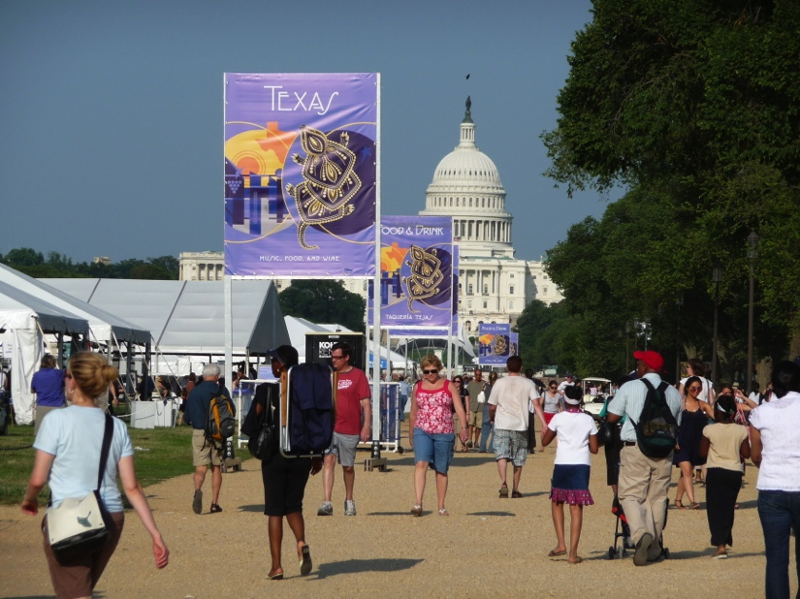

The National Mall has become the Stage for Our Democracy where 25 million visitors each year explore American history and heritage in our national museums and monuments, participate in cultural activities, Presidential inaugurations, Fourth of July festivities, and exercise their First Amendment freedoms.

**EXECUTIVE SUMMARY**

The National Coalition to Save Our Mall is entering a period of exceptional opportunities and challenges. It has established itself as a credible force on matters related to the National Mall and as the leading advocate of a bigger, more strategic understanding of the Mall’s role in American civic life and as the leading advocate for a public voice in matters related to the Mall. The organization’s National Mall Underground project could experience major breakthroughs in any of three channels in the near future. To achieve this it must balance collaboration and coalition building with its historic strength in advocacy and should contemplate a broader public engagement strategy. In that environment, it is moving from being led and managed by a very talented and dedicated Board to a being a more mature organization with the Board playing a governance role and staff managing the organization.

The Coalition has built itself up from a small citizens group in 2000 to a recognized voice for the public -- amongst government agencies that venture into planning on the National Mall without regard for the historic visions -- to protect and advance the historic planning principles that give the Mall its special beauty, symbolism, and public purpose as a stage for our democracy beloved by the American people. The historic 1791 L’Enfant Plan and 1901-1902 McMillan Plan established the Mall as a landscape symbol of American founding principles, and its function as centerpiece of American cultural and civic identity. The Coalition seeks to continue and re-imagine their vision today through a combination of advocacy, education, and creative planning ideas. The Coalition has successfully become a recognized “conscience” and a visionary voice for the Mall, but it needs to establish itself as a living, breathing organization with several responsible individuals and components before having the power to do more.

The strategic planning process conducted during summer and fall 2014 resulted in reaffirming the Coalition’s core mission and goals and in sharpening our focus on both long-term and short-term actions and strategies to achieve success in coming months and years:

* The Coalition will strengthen its role as: conscience for protecting the visionary planning legacy of the L’Enfant and McMillan plans with respect to all Mall projects and plans; developer of innovative ideas to advance a new visionary 3rd Century Mall plan; and leader in bringing together and collaborating with other nonprofits, government entities, business, and the general public on short-term and long-range visionary planning;
* The National Mall Underground proposal is the Coalition’s short-term focus and the first step toward the 3rd Century Mall: it embodies our approach to Mall planning, combining in one multi-purpose facility sustainable solutions to numerous Mall constituency needs and garnering strong support from federal and DC government, local residents and businesses, and tourism interests;
* New design and public programming proposals will be developed to continue to engage the public in advancing comprehensive, visionary thinking about the 3rd Century Mall.

To lead the transition to a more professional, well-funded organization, the Coalition will:

* Strengthen and build the Board with new members filling gaps in fundraising, community outreach, and other fields;
* Hire a President and support staff to professionalize the Coalition as a significant player in the local and national arena.
* Continue to build an effective public constituency for the Mall through education and outreach.

**TABLE OF CONTENTS**

**Executive Summary** page 1

**Table of Contents** page 2

**I. STRATEGIC PLAN** page 4

A. Need & Opportunity page 4

1. Overview of Problem and Need: Coalition’s History page 5

Importance of the Historic Plans page 6

Threats to the Historic Planning Legacy page 6

“Completed Work of Civic Art” Policy page 7

Coalition Mission and Goals page 7

A Vision for the 3rd Century Mall page 8

History of Coalition Mission-Drive Activities page 9

Coalition Today and Reason for Transition page 11

An Important Step: National Mall Underground page 12

Public Support for Coalition’s Advocacy page 13

2. Current Trends: Continuing Need for Our Coalition page 14

Continuing Need for Public Advocacy page 14

Continuing Need for New Visionary Plan page 14

Continuing Need for Unified Governance page 14

Ongoing Need for Innovative Proposals page 15

3. Root Causes: Historical Lack of Comprehensive Planning page 16

Piecemeal Planning but No Visionary Plan page 17

Basic Lack of Agreed-Upon Mall Definition page 18

4. Barriers page 20

Congressional Inaction and Defunding page 20

Coalition’s Sometimes Adversarial Relationships page 20

Competition Landscape page 21

5. Opportunity: Conscience, Innovation, & Leadership page 21

Renewing Old and Building New Alliances page 22

B. Social & Cultural Impact page 23

1. Update Mission and Goals page 23

Slightly Revised Mission page 23

Revised Vision for the 3rd Century Mall page 23

Design Principles for a Vision for the 3rd Century Mall page 24

Mission-based Goals page 25

Organizational Goals page 25

2. Social Impact Model page 26

Market Segmentation page 26

Political Landscape page 26

Performance Management and Impact page 26

3. Vision of Success page 27

3rd Century Mall page 27

National Mall Underground page 27

Organizational page 27

**II BUSINESS PLAN** page 28

A. Description of Existing Operating Model page 28

Coalition Operations: Current Work Culture page 29

Updated Organizational Goals page 29

B. Transition Activities page 30

Next Steps: Team and Governance page 31

C. Organizational Needs and Strategies page 32

D. Organizational Capacity Building page 33

Team and Governance page 33

Programs and Services page 33

Marketing page 33

Technology page 34

Public Policy page 34

Risk Mitigation page 34

E. Financial Sustainability page 35

Funding History page 35

Future Funding Needed page 36

Future Funding Sources page 36

Future Funding Structure page 36

Financial Management Needs page 37

F. Implementation Strategy page 37

Business Plan Timeline (Achieving Goals in 5 Years) page 37

G. Phase One Action Plan page 37

**I. STRATEGIC PLAN**

**A. NEED & OPPORTUNITY**

The National Coalition to Save Our Mall is entering a period of exceptional opportunities and challenges. It has established itself as a credible force on matters related to the National Mall and as the leading advocate of a bigger, more strategic understanding of the Mall’s role in American civic life and as the leading advocate for a public voice in matters related to the Mall. The organization’s National Mall Underground project could experience major breakthroughs in any of three channels in the near future. To achieve this it must balance collaboration and coalition building with its historic strength in advocacy and should contemplate a broader public engagement strategy. In that environment, it is moving from being led and managed by a very talented and dedicated Board to a being a more mature organization with the Board playing a governance role and staff managing the organization.[1]

The Coalition has built itself up from small citizens group to a recognized voice for the public -- amongst government agencies that venture into planning on the National Mall without regard for the historic visions -- to protect and advance the historic planning principles that give the Mall its special beauty, symbolism, and public purpose as a stage for our democracy beloved by the American people. The historic 1791 L’Enfant Plan and 1901-1902 McMillan Plan established the Mall as a landscape symbol of American founding principles, and its function as centerpiece of American cultural and civic identity. The Coalition seeks to continue and re-imagine their vision today through a combination of advocacy, education, and creative planning ideas. The Coalition has successfully become a recognized “conscience” and a visionary voice for the Mall, but it needs to establish itself as a living, breathing organization with several responsible individuals and components before having the power to do more.[2]

The Coalition’s multi-purpose National Mall Underground proposal – an underground storm water reservoir and parking garage facility that addresses a critical priority dealing with projected flooding of Mall area museums and public buildings such as occurred in 2006 -- is a feasible catalyst to this change. See more at <http://www.nationalmallunderground.org>. Developed in 2013 and 2014 in consultation and collaboration with nonprofits, government agencies, local business interests, and members of the public, this proposal has the capacity to advance the Coalition’s goals of creating a comprehensive, visionary Mall plan as well as boost the Coalition’s leadership role toward that end.

This Strategic Plan has been developed based on transition analyses and recommendations prepared by Raffa and by Transition Leadership International, whose reports are attached in Appendix A. Key recommendations include: finding an Interim Director and Long-term President with great skills at organizational collaboration; identifying missing/key staff positions needed to support goals; ensuring that the new President has a strong working relationship with Chair and Founder Judy Scott Feldman, who has been the main driving force for the organization until now; and, insisting during the transition process on “great focus, clarity, and accountability” which “requires specific goals, strategies and plans of action.”

The following is the Coalition’s statement of these goals, strategies, and plans of action.

**1. OVERVIEW OF PROBLEM AND NEED: COALITION’S HISTORY**

The National Coalition to Save Our Mall was founded in 2000 by a group of architects, historians, preservationists, and concerned citizens to protect and enhance the integrity of the National Mall, a national treasure, for future generations. Our goal was to build an organization that could speak for the public interest in the face of government-dominated planning and changes to the Mall. The immediate context in 2000 was our stand regarding the government-approved location of the World War II Memorial which violated the historical integrity of the L’Enfant Plan and the 1902 McMillan Plan for the nation’s capital. The Coalition strongly supported creation of the WWII Memorial but we opposed the location and design that interrupted the continuous open space design and symbolism of the Capitol-Washington Monument-Lincoln Memorial Mall axis.

The larger context for the Coalition’s founding was the realization that: there was no updated visionary plan to intelligently guide Mall development in the future; oversight for the Mall was fragmented among 8 government entities and 14 committees in Congress, leading to piecemeal planning and change that threatens the Mall’s integrity; Congress has declared the Mall a “completed work of civic art” but has made exceptions for the Vietnam Memorial Visitors Center, the National Museum of African American History and Culture, and other projects that continue to diminish the public open space; and, in the face of multiple government entities in charge the public interest was being ignored.

The Coalition has established itself since 2000 in four important aspects in advocating for this national treasure:

* a conscience for protecting the legacy of the historic 1791 L’Enfant Plan and the 1902 McMillan Plan that are blueprints for the Mall’s inspiring design and symbolic quality beloved by the American people (a legacy that is ignored or minimized in jurisdiction plans such as the National Park Service’s 2010 National Mall Plan and the Smithsonian’s 2014 South Mall Campus Master Plan).
* the only organization contesting the “completed” policy and instead promoting the need for a new visionary plan in the 21st century so the Mall can continue to evolve, grow, and support our ever-evolving democracy;
* an organized voice for the public interest on Mall matters, in the face of fragmented Mall oversight by numerous government entities but no meaningful voice for the public;
* a creator of innovative, visionary ideas and solutions to Mall problems that rise above jurisdictional interests and serve the larger needs of the public, e.g., National Mall Underground.

In 2004, the Coalition began using the “3rd Century Mall” terminology to explain our call for a new Mall plan that both respects the historic plans as well as updates those plans to meet modern needs. Thus, the 1791 L’Enfant Plan is the “1st Century Mall.” The 1902 McMillan Plan is the “2nd Century Mall.” And we advocate for the new visionary plan for the “3rd Century Mall” that advances that vision into the 21st century.

**The Importance of the Historic Plans**

For 223 years, the L’Enfant Plan has been the framework for planning in the capital. In 1791, President George Washington presented the plan to Congress and to the American public as a gift and a monument to his memory. That plan unites American Constitutional principles and enlightenment rationality -- in the geometric layout of the Capitol, White House, and public space of the National Mall –with a humanistic approach to urban design characterized by broad avenues, intimate residential streets, and plenty of park land and open space that has stood the test of time. It is the source for Washington’s design geometry, the symbolic relationship of buildings and public spaces, and the unique livability of the capital. It inspired the McMillan Plan of 1901-1902. When we have diverted from L’Enfant’s principles in the past, as with chaotic growth on the Mall during the 19th century, invariably later generations have recognized the mistake and reinstated those original concepts. Generations of planners and developers have respected that legacy, and agencies such as National Capital Planning Commission and the Commission of Fine Arts have been created to uphold the historic planning vision. However, the lack of an updated L’Enfant Plan for the 21st century coupled with modern development that often ignores L’Enfant planning principles threatens to destroy Washington’s unique planning legacy.[3]

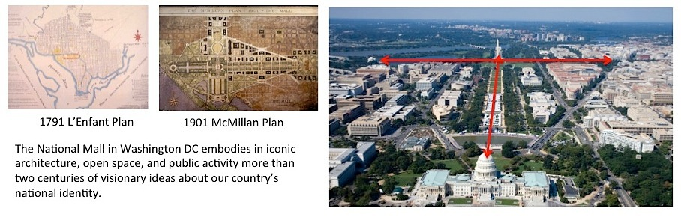

**Threats to the Historic Legacy**

The physical problems and structural needs that inspired formation of the National Coalition to Save Our Mall remain essentially the same as we described them in the our 2006 report,[4] attached in Appendix B:

The integrity of the National Mall is threatened by continuing calls for new museums and memorials, haphazard growth, uncoordinated security, and poor maintenance. There is no up-to-date master plan, no unified management or Congressional oversight, as shown in the diagram, and **not even agreement on the Mall’s definition**. Lacking visitor amenities, transportation systems, and convenient parking, the Mall is uninviting, cut off from the rest of the city and the local community. A commission is needed with the ultimate authority to unify management and create a comprehensive, forward-looking vision for the National Mall in the 21st century – the 3rd Century Mall.

**“Completed Work of Civic Art” Policy**

Congress in 2002 declared the Mall a “substantially completed work of civic art” in an attempt to prevent overbuilding with museums and monuments but has already made exceptions for a visitors center at the Vietnam Veterans Memorial and the National Museum of African American History & Culture. The National Park Service’s 2010 National Mall Plan took the complete policy as the basis for proposing basic maintenance and upgrade of NPS areas of the Mall without any vision for future growth or development. The Smithsonian’s 2014 South Mall Master Plan likewise focuses primarily on maintenance and upgrades. None of the 8 jurisdictions’ plans for the Mall as a unified whole or for the Mall’s long-term needs such as creating new places for Mall growth to accommodate the museums and monuments that are sure to come in future generations, and flood control.

The “completed” policy has not only failed to stop development; it has led agencies to focus on piecemeal improvements and to reject calls for a new visionary plan for the entire Mall. But the Mall cannot be complete any more than our history is finished. New museums and monuments will come with future generations and deserve to find a place in the American story told on the Mall. The Mall needs to grow again, as it did with the 1902 McMillan Plan, to accommodate ongoing history and public use. Any visionary plan for the future must recognize the Mall to be not complete but an ever-evolving landscape symbol of our national identity.

**Coalition Mission and Goals: Protect and Advance the Legacy**

Our mission statement has evolved since 2000 as we moved from a kind of watchdog group often opposed to government plans to a more proactive organization advocating creation of a **“3rd Century Mall”** plan that advances in the 21st century the legacy of the visionary 1791 L’Enfant and 1902 McMillan plans. **Part of the Strategic Planning process involves clarifying the mission statement from earlier versions to an updated, forward-looking one.**

In 2000, the stated mission was:

The National Coalition to Save Our Mall is a not-for-profit, 501c3 organization of designers, historians, artists, preservationists, and concerned citizens founded in 2000 to protect and enahnce the integrity of the National Mall.

From 2012 or so, a more developed mission statement is posted on the savethemall.org website:

The National Coalition to Save Our Mall is the only organized voice for the public on Mall matters. We are a nonprofit, 501c3 organization of historians, designers, and concerned citizens seeking a broad, visionary plan for the National Mall that recognizes the Mall’s value to all Americans as a symbol of American founding ideas, the People’s Place, and a stage for our evolving democracy. Founded in 2000, we are an all-volunteer group supported by individual donations from members across the country.

**The following updated mission statement, developed with the Raffa transition team, has been proposed,** for review by the Board:

The mission of National Coalition to Save Our Mall, in the face of fragmented government management, is to provide an organized voice for the public on National Mall matters; to advocate comprehensive, visionary planning for the National Mall in the 3rd century; and work in collaboration with government, nonprofits, and the business sector to implement forward-looking improvements that support the National Mall’s continuing role in American democracy. The Coalition, founded in 2000, is the only organization committed to speaking up for the public interest on Mall matters.

To advance our mission, the Coalition has articulated **3 main goals:**

* Creation of a **“3rd Century Mall”** plan that advances the legacy of the visionary **1791 L’Enfant Plan** and **1902 McMillan Plan** into the 21st century
* Congressional authorization of a new **McMillan-type Commission to create the 3rd Century Mall plan**
* Establishment of **unified governance** in an entity that represents the interests of the entire American public, as well as Mall managing agencies.

**A Vision for the 3rd Century Mall**

The Coalition realized early on that in order to excite interest and support in the 3rd Century Mall concept we needed to illustrate what we mean by a new visionary plan that advances L’Enfant planning principles. In 2006, after two years of public conversations and a design charrette at the Corcoran Gallery of Art (see below), the Coalition released a 5-page report that summarized the problem, the need, and a vision for the 3rd Century Mall. That report is attached in Appendix B. The still relevant vision it articulates for the 3rd Century Mall is the following:

In its 3rd Century, the National Mall’s historic landscape can enlarge its role as **grand stage for democracy** where Americans learn, meet, celebrate achievements, play, and seek redress of grievances in a national spotlight. It can be **expanded onto contiguous and other federal lands** and incorporate abundant frontage on the Potomac River. The expanded 3rd Century Mall can create inviting new public spaces, **strengthen the Mall’s connections with the Washington metropolitan community** and surrounding neighborhoods, and make room for future museums, monuments, and cultural and recreational activities, while extending and reinforcing the Mall’s symbolic narrative. More than ever, the 3rd Century Mall can **showcase American founding ideals, history, art and culture, technology, and sustainable landscaping.** The Mall in its 3rd Century can fulfill its intended role as the people’s place by continuing to embody, as it did with civil rights and other public events great and small in the 20th century, the **centrality of the people in America’s ever-evolving democracy**.

**History of Coalition Mission-Driven Activities & Advocacy**

In the past 14 years, the Coalition has made strides in educating the public, Congress, and government agencies with jurisdiction over the Mall about the Mall’s history and planning legacy, as well as in promoting thoughtful, intelligent planning to ensure the Mall continues its important role in American democracy. Our work has included: educating government and the public in personal briefings and on our website; delivering testimony before Congress and government review agencies on Mall projects to support protection of the historic plans; holding public forums to engage the public in discussing the Mall’s future; collaborating with other nonprofits to build support for Mall improvements and to oppose destructive projects; and proposing creative solutions to Mall problems not being addressed by existing Mall managing agencies. The Washington Post editorial board has enthusiastically endorsed Coalition ideas including Mall expansion, creation of a new McMillan-type commission to prepare the 3rd Century Mall plan, and the National Mall Underground flood control/public access proposal.

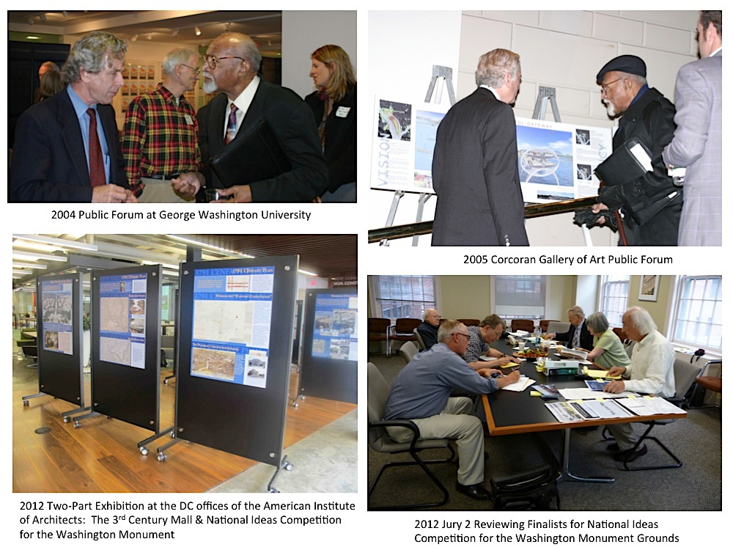

In 2004, the Coalition launched the National Mall 3rd Century Initiative to engage the public in thinking about short-term and comprehensive long-term planning and to propose innovative solutions to

modern needs not addressed on Mall managing agency plans. That year, to raise public awareness and gather public input about the future of the Mall, we held four public forums at George Washington University and published the findings in “The Future of the National Mall.” Visit the website for this early project at <http://www.nationalmall.net> .

At the Coalition’s “Designing for Democracy” public forum at the Corcoran Gallery of Art in 2005, we invited 6 architects to show concepts for expanding the Mall, what we call the “3rd Century Mall,” to provide new space for future museums and public activities while protecting the historical Mall. The focus of all 6 designers was the underutilized island of East Potomac Park on which the Jefferson Memorial is located.

In 2008, the Coalition worked with graduate students at George Mason University who prepared a Mall circulation study that identified problems with pedestrian circulation, public transportation, parking, and general access to the monuments, museums, and cultural activities. That study and its recommendations for better circulation planning and options laid the groundwork for our continuing efforts to improve access and circulation including development of the National Mall Underground proposal in 2013 and 2014.

In 2009, drawing upon our ongoing outreach to the public in meetings and public forums, as well as ideas by Coalition Board members and leadership, we proposed design and program ideas for how the Mall could be improved in “Renewing American Democracy on the 3rd Century Mall.” One action item in that 2009 report was to organize a public competition for the unfinished Washington Monument Grounds to educate the public about Mall history and engage citizens of all ages in thinking creatively about the future of the Mall. This became a major project for the next two years.

Beginning in 2010 and ending with announcement of a People’s Choice winner in 2012, the Coalition sponsored, with George Washington University and many other educational institutions, a National Ideas Competition for the Washington Monument Grounds. The competition drew more than 500 participants from across the country and around the world. Contestants were asked to honor the historic L’Enfant and McMillan plans while creating new ways to make the barren, unwelcoming Washington Monument grounds the Mall centerpiece and oasis it was intended to be. Visit the website at <http://www.wamocompetition.org> .

In 2012 we mounted two public exhibitions at the District Architecture Center (offices of the DC Chapter of the American Institute of Architects), one focused on the 3rd Century Mall concept and the other on the process and winners of the Washington Monument Competition, to further engage the public in an ongoing conversation about the Mall’s future.

Ongoing day-to-day activities by members of the Board include participating in and collaborating with other organizations on: public meetings for Mall-related projects, preparing and presenting thoughtful testimony to Congress and during design review hearings, and informing the public via our website and email updates of relevant Mall issues. The Coalition has been part of the public consultation process in recent years for numerous projects including Washington Monument security, the National Museum of African American History and Culture, the Vietnam Memorial Visitors Center, the National Park Service’s National Mall Plan, the Smithsonian’s South Mall Campus Master Plan, and security for many museums, monuments, and public buildings. **The Coalition is often quoted in the media as a voice for the public interest on these government-drive projects.**

Educational outreach since 2000 includes hundreds of free public talks by the Chair Judy Scott Feldman on the history and future of the Mall to school and civic groups, Elderhostel, Road Scholar, the Trust for the National Mall, and others. Working with interns from George Washington University, the Chair developed the first of a proposed series of self-guided tours of the Mall focusing on civic themes. This “America’s Struggle For Freedom” tour, printable from our website on one 8 x 11 sheet of paper, uses the Jefferson, George Mason, FDR, and Lincoln Memorial to explore concepts of the Revolution, Declaration of Independence, US Constitution, Bill of Rights, Four Freedoms, and Civil War/Civil Rights. Our 2009 report proposes 7 additional tours on different themes intended to educate and build civic knowledge.

Another very popular project of public outreach is our mini-map “National Mall: Stage for Our Democracy.” This pocket-sized map is the only Mall map to show the entire Mall as envisioned in the historic L’Enfant and McMillan Plans and to tell the inspiring story of public use of the open space through time for civil rights, First Amendment, and other activities. Since 2005, we have distributed over 220,000 maps, primarily at three main locations: Congressional offices, through the service First Call; Ronald Reagan National Airport; and Dulles International Airport.

**Coalition Today and Reason for Transition**

What Raffa consultants Tom Adams and assistant Melanie Thomas initially recognized and subsequently analyzed in May 2014, and what transition consultant Pat Nichols later built upon over the summer of 2014, was the unique position the Coalition has carved out for itself in the DC/Federal government community. With extremely limited manpower and resources, and at times uncertain support, the Coalition has become a respected, though frequently unpopular, voice on all things National Mall-related. Not only has the Coalition been arguably successful in becoming a household name for large government agencies such as the National Park Service and NCPC among others, but it has also solidified its presence as a true “conscience” to all bureaucratic planning agencies involved in Mall matters. Board members have established good rapport at high levels with many of the DC and federal government agencies.

Raffa, Nichols, and future consultants recognize the enormous potential of this organization in the right hands. If the Coalition has achieved this much to date as such a small volunteer initiative, reorganizing itself to include a staffed, dedicated, accountable (paid) team and fulltime leadership could exponentially increasing its influence and strength. However, the success going forward depends strongly on the adherence to the Coalition’s mission, vision, and highly principled, creative personality. To continue its work and to become a larger manifestation of this “conscience,” a work culture and staff must be built around these ideas.

The Coalition realizes after 14 years of effort that our impact on government decisions is limited. Despite recognition in the local community and media that the Coalition is an intelligent voice in Mall-related matters, the organization is identified as a one-woman operation (the Chair) and thus is too easy to ignore or dismiss as a real force in the highly politicized Washington government-dominated planning community. That needs to change.

At the same time, we have reduced our day-to-day involvement in government projects and the public consultation process because of our limited impact in a political and bureaucratic environment. What we are learning is there may be more efficient ways to impact decision-making.[5]

**An Important Step: The National Mall Underground**

A major impetus for the transition to professional leadership is the Coalition’s National Mall Underground proposal -- an underground storm water reservoir and parking garage facility that addresses a critical priority dealing with projected flooding of Mall area museums and public buildings such as occurred in 2006 while also providing a much-needed Mall welcome center and visitor amenities. More so than earlier Coalition proposals, this project has taken on a life of its own and needs strong Coalition leadership and commitment.

Developed in partnership with local philanthropist and businessman Albert H. Small and renowned architect Arthur Cotton Moore FAIA, the National Mall Underground has the capacity to achieve two significant goals as we move our organization to the next level**.** Its innovative, multi-purpose flood and public amenities components advances the Coalition’s 3rd Century vision for the Mall as a lively and resilient public space. And, this popular, consensus-building, and achievable short-term project can boost the Coalition’s leadership role on Mall matters. **The goal with this project is that it is “branded” as a first step toward the 3rd Century Mall.**[6]

Already this proposal is building coalitions and garnering national interest. Developing the concept since 2013 has led us into a new, exciting level of consultation and collaboration with federal and District of Columbia agencies, Congress, other nonprofits, and the public. And **it has shown what can be accomplished with visionary thinking that rises above jurisdictional plans**: it consolidates in one project the multiple needs of government and Mall visitors, with a credible self-funding component to lessen costs to the public.

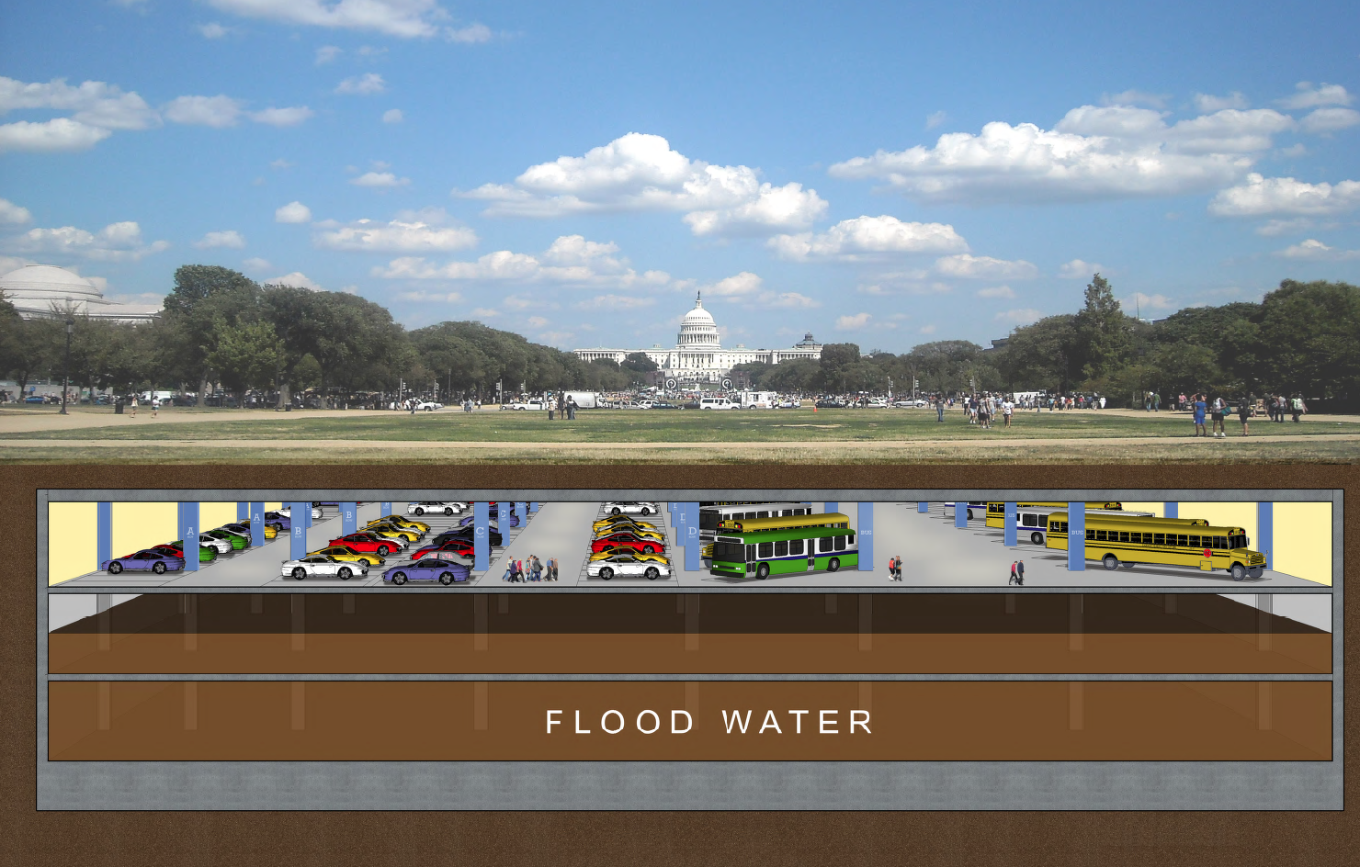

The strong feasibility of the NMU project moving forward, and of the Coalition being an important player in its design, funding, and implementation, is an added boost to the Board’s decision to move the Coalition to the next level and hire professional staff.

**Public Support for Coalition’s Advocacy and Outreach**

The National Mall Underground proposal is the most recent project that has won the Coalition support from other nonprofits, commentators, and newspaper editorial boards. The Coalition’s **principled opposition** to projects, based on our goal to protect the historic L’Enfant and McMillan Plans, and our promotion of comprehensive, visionary planning has drawn others to our side. During the World War II Memorial controversy, the great majority of art and architecture critics, political pundits across the political spectrum (including conservative George Will and liberal Bill Press), as well as national newspaper editorial boards, agreed with the Coalition’s stand against the government agency approvals of the Mall location at the Lincoln Memorial Reflecting Pool, on the Mall’s historic Capitol axis.

Since 2005, the Coalition has garnered support for our Mall expansion and other ideas, as well as our opposition to controversial Mall projects, from The Washington Post and other prominent, national media. Examples include a 2005 Washington Post editorial supporting Mall expansion and another editorial promoting the Coalition’s idea for an independent commission to prepare the new visionary plan for the Mall, and to implement it. Architectural critics Benjamin Forgey (formerly Washington Post), Christopher Knight (LA Times), and others have criticized the lack of visionary planning by government and supported the Coalition’s call for an independent commission to plan the Mall’s future.

The Coalition has built support for creating a comprehensive plan for the Mall among a number of nonprofit groups including the National Trust for Historic Preservation, the DC Preservation League, the National Parks Conservation Association, and others.

The Coalition often works on specific issues and controversies with other organizations to oppose bad plans that would destroy the Mall’s historic integrity. For example, in opposing the Vietnam Memorial Visitors Center and the proposed security tunnel into the Washington Monument we collaborated closely with the National Trust for Historic Preservation, the National Parks Conservation Association, the DC Preservation League, the National Association for Olmsted Parks, and the Committee of 100 on the Federal City. **There is opportunity to develop issue-based coalitions through these alliances**.

Media contact us when they want to understand an issue or want a quote on a controversial matter.  A recent example: In September 2014, the Coalition’s Chair has been quoted in newspaper articles and radio with regard to a security breach at the White House as urging protection of Washington’s public open space and not overreacting to safety fears with new security barriers.

In recognition of the Coalition’s strong advocacy for the Mall, the Coalition’s Chair has received the following awards: Committee of 100 on the Federal City: Vision Award (2002); DC Federation of Citizens Associates: Vision Award (2005); Committee of 100 on the Federal City: Vision Award for Lifetime Achievement (2010).

**2. CURRENT TRENDS: CONTINUING NEED FOR OUR COALITION**

As the Coalition transitions to a professionally staffed organization, the Coalition’s historic mission continues to be relevant, even more so now than in 2000. The task is to take the Coalition’s efforts to the next level.

**Continuing Need for Public Advocacy and Coalition Building**

The public interest is a key element of the Mall’s historic and modern meaning as well as the proposed long-range, comprehensive and visionary plan for the 21st century. But the public has no meaningful role in decision-making or planning. The Coalition is still the only organized voice for the public on Mall matters and will continue to be that as it continuously promotes public-spirited proposals that benefit the entire American public.

**Continuing Need for a New Visionary Plan**

No one plans for the entire Mall, as a unified symbolic landscape in the historic and holistic tradition of L’Enfant and McMillan plans, as a symbol of American identity, and as a public space that plays an active role in American democracy. Congressional policy that declares the Mall “completed” has both stymied momentum for creating a new McMillan-type commission to do a new visionary plan for the future and led federal agencies to plan small-scale maintenance projects instead of looking to solve long-range problems with innovative ideas.[7] Continuing their usual practice, the eight-plus Mall managing agencies each plan for their buildings and open space on the Mall, and their own priorities and needs. Absent an updated visionary plan, uncoordinated, piecemeal development continues to undermine the integrity of the Mall. The public has no meaningful role and so is powerless to compel positive change.

Furthermore, unmet needs pose a threat to the Mall’s future resilience, its historic integrity, and its ability to support public activities. Government plans do not address urgent problems such as flooding of Mall area buildings, streets, and public space that most recently occurred in June 2006, and is predicted to intensify in coming decades due to the effects of climate change. Nor do current plans provide solutions for the continuing need for new locations for future museums and monuments, and for modern public events such as the National Book Festival (which has been denied a permit for the Mall by the National Park Service in order to protect the new turf grass). Where will future museums go so as not to destroy more of the Mall open space? What kind of policies are needed to support public use instead of rid the Mall of its lively cultural activity?

**Continuing Need for Unified Governance**

Ultimately, to overcome uncoordinated and piecemeal planning, management, and implementation of Mall projects what is needed is a new entity to bring all Mall constituencies, including representatives of the public, to the table to collaborate on comprehensive planning and implementation. The Trust for the National Mall, the National Park Service’s fundraising partner, is doing important work in raising funds to implement much-needed maintenance and upgrades for Park Service-managed areas of the Mall. The larger need for all constituencies is an entity that looks to big-picture, comprehensive, and visionary thinking that builds on the visionary planning legacy for the entire Mall to support modern needs in the 21st century. Without such a unified entity, current piecemeal growth of new memorials and museums will propel change authorized project by project by Congress and once again the larger public need for amenities, services, and public gathering spaces will not receive the priority that is needed.

Such a Mall management entity would likely have to be created by Congressional directive and receive federal appropriations, a goal that seems unlikely in the current political climate. Alternatively, creation of an entity (such as New York City’s Central Park Conservancy) to advocate, raise funds for development, and provide a public voice is a possibility. The CEO and the President of New York City’s Central Park Conservancy, both of whom headlined our inaugural 2004 public forum, gave insights into the history of that organization and advice about building that kind of public-private partnership that engages all constituencies in collaborating, -- in planning, fundraising, and implementation -- for the good of the entire community.

**Ongoing Need for Innovative Proposals of Visionary Planning**

Until some kind of Mall Conservancy or other public collaborative entity is created, the Coalition’s strategy is to devise projects that, on a small scale, bring parties together to plan for the larger good of the entire Mall and the American public. In addition, these projects are intended to encourage big-picture thinking that consolidates the needs of all constituencies, instead of creating separate projects serving individual agency/interest needs.

The Coalition’s proposal, first put forward in 2004, to expand the Mall to East Potomac Park and other underutilized federal land along the Potomac and Anacostia waterfronts has gained support from The Washington Post, Congresswoman Eleanor Holmes Norton (D-DC) and other national media voices. Public support continues to grow and our short-term goal of collaborating with other groups and government agencies on a public competition for East Potomac Park will further build excitement for Mall expansion.

Mall boundaries can be expanded on the 3rd Century Mall to include federal lands on both sides of the Potomac and Anacostia Rivers.

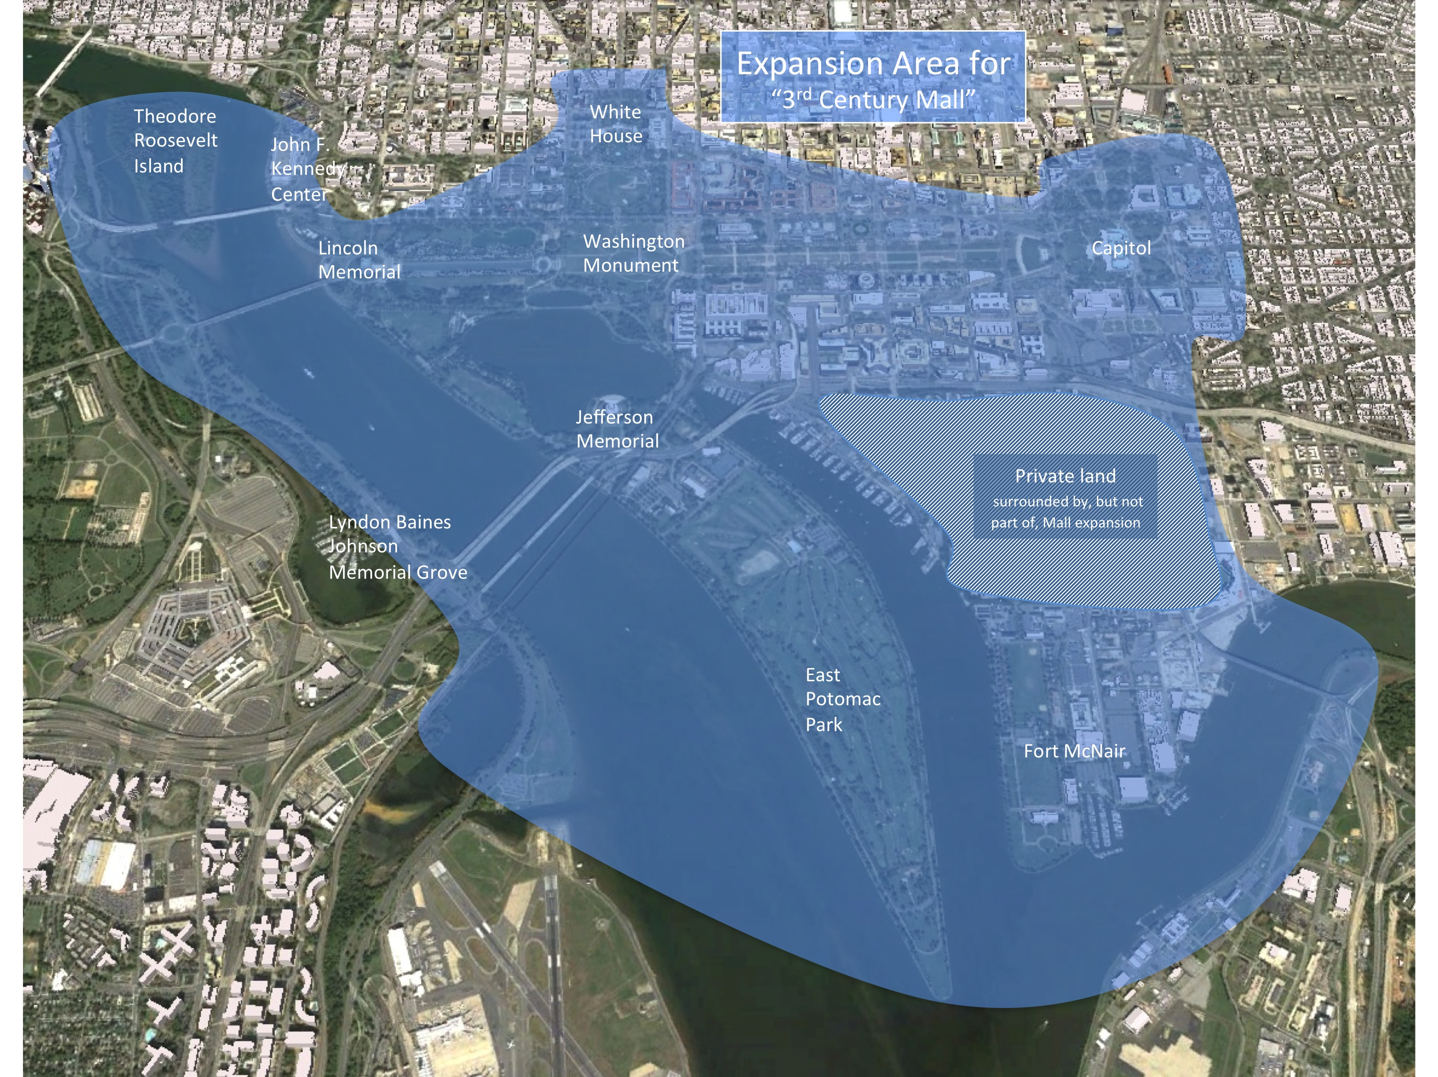

The National Mall Underground proposal is the most exciting short-term project that has the capacity to raise the Coalition’s public visibility and to advance our mission. After 2 years of meetings with government agencies and leadership, members and staff in Congress, and members of the public, the project is well developed. Next steps include continuing to build project-based coalitions and partnerships to advance this project. The Army Corps of Engineers is seriously considering making a feasibility study, in collaboration with DC Government and the Coalition, and then implementing the plan if authorized by Congress.

Additional opportunities for collaborative planning and development include the Coalition’s proposal for a long-range resiliency plan for East Potomac Park that conceives of this underutilized landfill area as part of a 3rd Century Mall expansion, as a laboratory for resilience planning, and as a welcoming new destination serving local residents as well as out-of-town visitors.

**3. ROOT CAUSES: HISTORICAL LACK OF UNIFIED PLANNING**

Although the National Mall is a symbolic landscape expression of American democracy and self-governance, the basic problem with charting the future is the lack of any unified entity or authority to represent the interests of the American public. In fact, the Mall never has had unified management or oversight. Congress since 1791 has transferred jurisdiction of Mall buildings and open spaces to various different federal and DC authorities. In the 1930s, Congress transferred authority of the open space and monuments to the National Park Service.

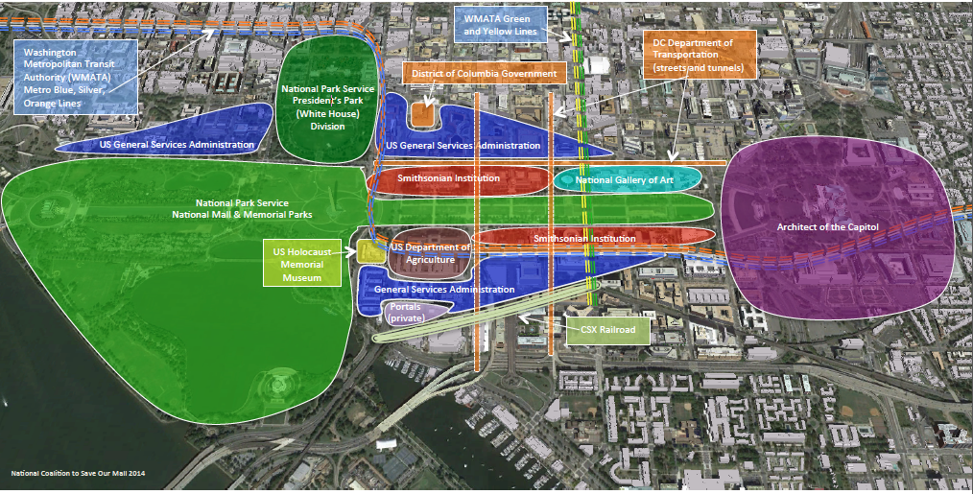

Since the 1930s Congress has continued to carve out buildings and spaces for other entities: the Smithsonian has been given new Mall land to build new museums; the Architect of the Capitol has control over the eastern portions of the Mall; the National Gallery of Art controls two museums and a sculpture garden; US Department of Agriculture houses offices on the Mall. In Congress, oversight is even more complicated: 14 different committees have jurisdiction over Mall managing agencies and memorial, museums, and other Mall-related matters. None of the existing managing entities has the authority, the interest, the finances, or the mandate to create a unified Mall plan that benefits all Americans.

To remedy this lack of unified authority, a key Coalition goal is to succeed in the creation of a unified governance system, with strong public participation, that can create the 3rd Century Mall Plan, raise funding for that plan, and implement that plan.

**Piecemeal Planning But No Visionary Plan**

Despite the reality of fragmented authority for the Mall, one agency, the National Park Service, claims that it is the steward of the Mall. As a consequence, most people, including many Congressional leaders, think that the National Park Service controls the Mall and so defer to that agency. This further complicates and confuses Mall planning and public use decision-making to the detriment of the larger public interest. The fact that NPS’s National Mall Plan accepts that the Mall is “completed” and so proposes only maintenance and upgrades but no larger solutions to the larger needs of all Mall constituencies leaves Mall planning in a stagnant situation.

The cover of the National Park Service’s National Mall Plan illustrates NPS’s monument-by-monument piecemeal approach to planning for the Mall.

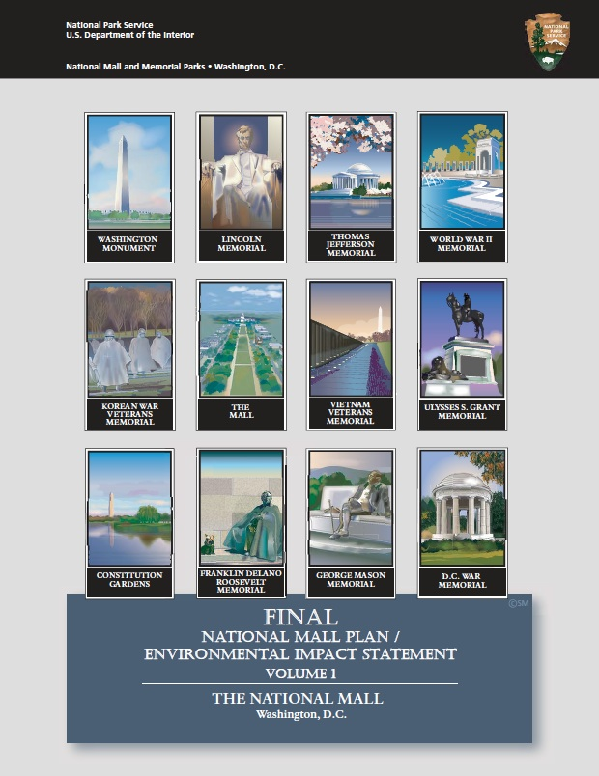

For example, Congress gave the NPS $5 million to prepare a new plan for the Mall, and thinks that NPS’s plan is the new comprehensive Mall vision. However, that plan, completed in 2010, is a maintenance plan (not a public use plan) only for parts of the Mall under NPS jurisdiction. That plan treats the grass as a precious “natural resource” that must be protected from public use. As illustrated in the cover of the final plan, that plan treats each memorial as a separate “cultural landscape” but not part of the Mall as a unified concept and design as intended in the L’Enfant and McMillan Plans.

Instead of improving the Mall’s openness to public use, the new NPS plan has caused conflict with other Mall constituencies including the Smithsonian and the Library of Congress who program cultural activities on the open space. Arguing that the turf grass and other natural resources must be protected, NPS has denied permits to historically popular public events and celebrations such as the Smithsonian Folklife Festival and the Library of Congress National Book Festival.[8]

While other Mall managing entities clearly understand the NPS’s Mall plan is not a blueprint for the entire Mall, these agencies have not supported creation of a McMillan-type commission. On the contrary, they have told Congress that such a commission would duplicate their own planning efforts. In fact they defer to NPS on Mall matters. The National Capital Planning Commission, the one federal entity with authority to bring all Mall constituencies to the table to do comprehensive planning, has declined to do so and instead has deferred to the NPS, which has a seat on the NCPC.

Congressional funding for individual Mall improvements reinforces this piecemeal and ultimately destructive (to the historic planning legacy) approach to Mall planning. Congress provides funding for individual museums and monuments approved for the Mall. Agency budgets requiring depletion of funds at the end of each fiscal year promote short-term planning and development. (NPS ignores the Coalition’s National Mall Underground project since this non-NPS proposal could affect its own plans, funded by Congress, to replace turf grass in the proposed location, between 9th and 12th Streets on the Mall.) The NPS’s fund-raising partner, the Trust for the National Mall, helps raise money to implement other elements of the Mall Plan, and so focuses on separate site-specific maintenance goals, the latest being to upgrade the landscape at Constitution Gardens near the Vietnam Veterans Memorial. Progress on implementing the NPS National Mall Plan may improve maintenance but does nothing to address the larger Mall needs.

Mall problems and needs, however, continue to grow in 2014 and the need for a new McMillan-type visionary plan becomes more acute. Many Congressional leaders, government entities, and members of the public increasingly recognize the limited scope of the NPS plan and the need create a comprehensive Mall plan to address larger, urgent needs such as identifying more land for future

museums and monument and public uses, improving visitor amenities, protecting resources from flooding. Examples include: sponsors of the Women’s History Museum and a World War I Memorial are looking for a location on the Mall; tour buses lacking parking roam city streets contributing to congestion and pollution; flooding devastates the Mall area, public buildings, and cultural resources.

**Basic Lack of Agreed-Upon Mall Definition as a Basis for Unified Planning**

While the L’Enfant and McMillan plans are the historical sources for the idea, design, and symbolic quality of the Mall, the Mall’s 8 managing agencies instead use their own agency-based definitions for the Mall. None of the government agencies even agree on a basic definition of the Mall’s geographic boundaries and purpose, a fact the Coalition has documented in historical research, which we have provided freely to government planning authorities and review agencies. The conflict is now acknowledged by these agencies but no one has taken up our request to create an agreed-upon definition.

Thus the Smithsonian’s map of the Mall shows only the area between 3rd and 15th Streets where the museums are located. The National Park Service defines the Mall in a variety of different ways, sometimes including only the museum area and in other contexts to include the Lincoln and Jefferson Memorials. Most curiously, the NPS administrative unit “National Mall & Memorial Parks,” which most people think refers to the Mall area in fact encompasses not only the Mall but also a host of federal park land scattered throughout the entire area of Downtown Washington. From the NPS perspective, the Mall is only one portion of a larger park jurisdiction. As for the Mall’s purpose, for the Smithsonian the Mall’s role is directly associated with its educational and cultural mission while for NPS the grass and trees are a priority. These competing interpretations have led to conflict over which takes priority, with the NPS increasingly refusing permits for large public events such as the National Book Festival and Smithsonian Folklife Festival.[9]

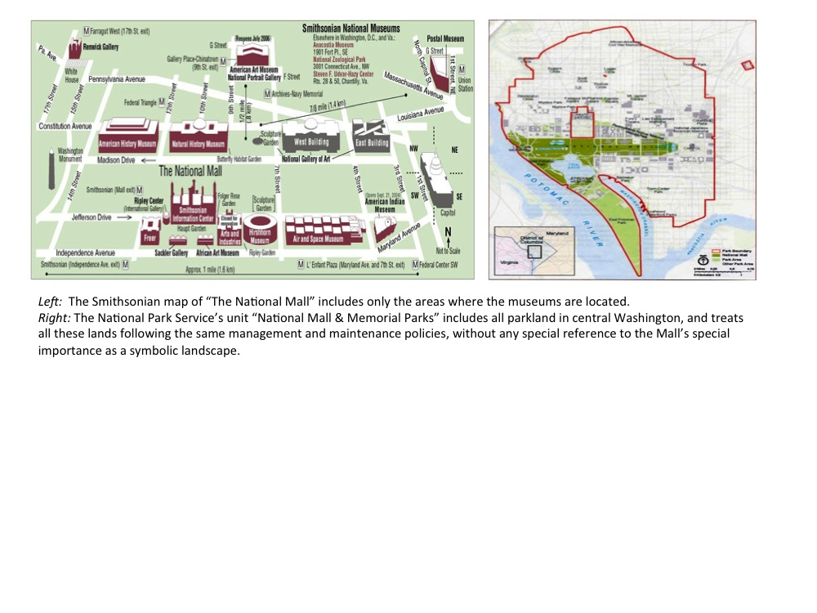

In fact, these various non-historical definitions are in direct conflict with the definition put forth by Congress in the 1986 the Commemorative Works Act. In the Act, enacted “to preserve the integrity of the comprehensive design of the L’Enfant and McMillan Plans for the Nation’s Capital,” Congress defines (as L’Enfant and McMillan did) “the great cross-axis of the Mall in the District of

Columbia, which generally extends from the United States Capitol to the Lincoln Memorial, and from the White House to the Jefferson Memorial.” But Congress does not enforce this definition so Mall managing agencies continue to ignore the historic concepts, which further threatens the integrity of the Mall as intended in the visionary plans.

The first step in remedying the current fragmented and piecemeal approach to planning is to establish agreement by all Mall constituencies to define the Mall’s boundaries and purpose consistent with the historic visions.

**4. BARRIERS**

**Congressional Inaction and Defunding of Mall-Related Agencies**

In recent years the National Park Service and Smithsonian have faced constraints on resources and escalating costs, including dealing with a substantial backlog of maintenance projects. As a result, these agencies have relied more heavily on private funding. The NPS partner Trust for the National Mall is working to raise money for NPS maintenance needs. Other Mall-related government agencies, unlike NPS, are not permitted to accept private funds, further limiting the government’s capacity to plan on the comprehensive scale needed for the Mall as a whole.

Congress believes that the $5 million it provided for the National Mall Plan already produced the much-needed long-term visionary plan for the Mall. NPS, the National Capital Planning Commission, and the US Commission of Fine Arts all assured Congress that that was the case and advised Congress not to create a McMillan-type commission when Sen. Craig Thomas (R-WY) stated his intention to do so in 2005. But these federal agencies all now acknowledge that the NPS plan is not the new visionary plan.

However, Congress shows little interest in revisiting Mall planning, despite calls by the National Coalition to Save Our Mall and other nonprofits including the National Trust for Historic Preservation, the National Parks Conservation Association, and the DC Preservation League to create a new McMillan-type commission to create the new comprehensive plan. The Coalition has sought Congressional action to create a commission since 2000 and needs to extend our outreach to build a national constituency calling for the commission. In the meantime, until that long-term goal can be achieved, the Coalition continues to find ways to make incremental progress toward the 3rd Century Mall.

**Coalition’s Sometimes Adversarial Relationships with Government Agencies**

The National Coalition to Save Our Mall is an independent organization. The organization is not always aligned with the government, and on several occasions has provided intelligent alternative solutions for the government to consider. This does not always make the organization popular.[10]

Ultimately, because the Mall is federal land, deeded to the US Government (not to NPS or other Mall managing agencies as many people think), Congress or the President will be required to authorize creation and implementation of the long-range plan for the Mall and any new governance body for the Coalition to achieve its final goals. The way to get there is to provide leadership by organizing the public locally and nationally, and working collaboratively with the national public as well as relevant government entities, to give effective voice to the public interest and ultimately to win Congressional approval of our mission and goals.

The Coalition’s public advocacy role sometimes leads to tensions with agencies including National Park Service, Smithsonian Institution, National Capital Planning Commission, and Commission of Fine Arts. They are wary of the Coalition taking a public position on issues. They would prefer we support their decisions. This makes communication and collaboration difficult, as they fear the Coalition’s disapproval and the publicity that might arise. When opposed, the agencies rally in support of one another and against our positions and advocacy. Nonprofit allies can also be reluctant to support the Coalition’s advocacy when it might jeopardize their sometimes delicate relationships with those agencies.

Many prominent people (designers, architects, historians) have congratulated the National Coalition to Save Our Mall on its work, but because they fear that their participation in the organization will stymie their progress in Washington, DC, their alliance and participation with the organization has to be kept confidential. Thus, much of the organization’s support is confidential because it cannot afford to be transparent. [11]

**Competitive Landscape**

The main non-governmental Mall-related entity is the Trust for the National Mall, the fundraising partner of the National Park Service. In conversations with Coalition members, the Trust leadership has stated that a National Mall Conservancy is not needed because the Trust considers itself to be the Mall Conservancy. The Trust acknowledges that its focus is NPS lands and priorities and that it has no authority to evaluate and support other Mall managing agency needs or the larger public interest for the Mall.

Because the Trust is bound by agreement with NPS to support the National Mall Plan and NPS proposals, and to raise money for government plans, we are sometimes in agreement and sometimes in disagreement with their plans. Usually, we try to both find common ground with them and minimize any public opposition.

The Trust and the Coalition have to date had different funding models. Whereas the Coalition has sought to maintain its independence by seeking funding in a few foundation grants and mostly contributions from individuals, the Trust is heavily funded by large corporations. We make no attempt to impede their fundraising efforts, though the Trust seems to think our efforts do impede their fundraising work on behalf of NPS. As a result of the Coalition transition process, fundraising needs may put us in greater competition with the Trust. The National Mall Underground project, which can be funded as a public works-private sector funding effort, has the potential to dramatically shift the Coalition’s financial status vis-à-vis private investment.

**5. OPPORTUNITY: CONSCIENCE, INNOVATION, & LEADERSHIP**

Outside consultants have recognized the great potential of this organization at this key period in its history (i.e., with growing support and alliances created around the National Mall Underground). Furthermore, if the Coalition has been seen to achieve such a strong voice in the community as little more than a grassroots, volunteer initiative, building the Coalition into a functioning, self-sustaining organization should render it stronger and more influential. More than ever, with growing threats to the Mall’s historical integrity (and government agencies failing to protect the L’Enfant legacy), and lack of a visionary plan for the 21st century, the Coalition’s strengths as a conscience for principled planning and for innovative and visionary leadership give us a meaningful role in the Mall’s future.[12]

With government unable and unfunded to move on Mall improvements, the time is ripe for the Coalition working with the public, other non-profits, and the private sector to take the lead. The Coalition has a long history of working on Mall matters with other groups and the public, and often closely with all relevant government agencies on projects on which we agree. We have developed ideas that go well beyond the jurisdictional planning done by government and address the larger, long-term needs to support the Mall’s vitality through the 21st century. Thus, the Coalition is ready to move our organization to the next level to lead a stronger effort to build coalitions, promote and advance innovative, visionary planning for the 3rd Century Mall, raise funding, and, create some kind of Conservancy-like governance entity to help move forward planning and implementation of the 3rd Century Mall. Whereas currently the Chair makes major decisions about what issues to step into and how to communicate goals and Coalition positions on issues, that somewhat episodic approach to operations will be replaced with greater organizational depth and cohesion.

These organizational changes are also necessary to support effective fundraising efforts. Foundations and corporations, especially, frequently require a strong strategic planning structure, board structure, sound finances and communications backbone in order to provide funding. Likewise, new Board members will require a professional governance structure that includes clear roles and responsibilities, a policy and committee structure, sound financial reporting and directors’ and officers’ insurance.[13]

**Renewing Old and Building New Alliances**

The landscape in which the Coalition navigates is a difficult, tricky, and unpopular one. Agencies have consistently both denounced and sought advice from the Coalition, often at the same time. However, even adopting unpopular viewpoints has garnered respect for the organization. What is interesting is the high level of notoriety the Coalition and the Chair have achieved through a grassroots-type identity, scrappy attitude, and unflinching perseverance in the face of adversity. Though they may remain secret for the most part, the Coalition has made many powerful friends that extend throughout DC and in DC and the Federal government as well as in the business and nonprofit community.[14]

The National Mall Underground project already is proving to be a good example of a Coalition project around which to renew old associations and build new alliances with the public, civic and nonprofit groups, the business community, and others. The Underground embodies the Coalition’s goals of forward-looking planning that engages all Mall-related government and nonprofit entities in a collaborative project, one that can be mostly privately funded and benefits everyone. Within the larger context of the 3rd Century Mall concept, the National Mall Underground is a focal point for short-term success that also points to the value of our long-term goals.

Another promising potential project for building on old alliances and establishing new ones is in developing a program and/or public competition to rethink East Potomac Park and Hains Point. This 330-acre area of landfill containing the Jefferson Memorial floods regularly, has aging and failing infrastructure, and is prime land for Mall expansion and for creating recreational space to serve the capital and District residential development along the Southwest Waterfront. The area is managed by the NPS which, however, has no long-range plan but has indicated an interest in collaborating on such a plan.. This is a project with which the Coalition can build a coalition among the public and federal and DC government and private interests.

Individual, short-term projects such as these are one strategy for building interest, support, funding while the Coalition continues to urge Congress and the President to create an independent Mall commission and visionary plan. They represent discrete, doable projects that can potentially be privately funded and so move us step by step toward realization of a more resilient and forward-looking National Mall, a fully developed 3rd Century Mall visionary plan, and a new public-centered Mall governance entity.

**B. SOCIAL & CULTURAL IMPACT**

**1. UPDATE MISSION AND GOALS**

At this period of transition from an all-volunteer to professional-led organization, the Coalition recommits to our still relevant mission, our vision for the 3rd Century Mall, and our goals. In light of the National Mall Underground project, and other possible collaborative proposals for individual Mall improvement projects, we update the goals to give greater prominence to these short-term proposals, which we see as first steps toward the 3rd Century Mall.

**Slightly Revised Mission**

The mission statement is as stated above with a slight modification in the last sentence:

Themission of the National Coalition to Save Our Mall, in the face of fragmented government management, is to provide an organized voice for the public on National Mall matters; to advocate comprehensive, visionary planning for the National Mall in the 3rd century; and work in collaboration with government, nonprofits, and the business sector to implement forward-looking improvements that support the National Mall’s continuing role in American democracy. The Coalition, founded in 2000, is the only organization **that regularly speaks for the public interest on** Mall matters.

**Revised Vision for the 3rd Century Mall**

Since 2006, we have developed somewhat different language to describe the vision for the 3rd Century Mall. We propose here two options, one longer and one shorter.

* A shortened and amended version of the vision for the 3rd Century Mall, first stated in 2006 (see above, p. 7), is:

In its 3rd Century, the National Mall can enlarge its role as an inspiring symbol of American founding principles and a civic stage where Americans explore their history and heritage, celebrate achievements, play, and seek redress of grievances in a national spotlight. Expanded onto contiguous and other federal lands along the Potomac and Anacostia Rivers, the 3rd Century Mall can create inviting new public spaces for future museums, monuments, and cultural and recreational activities, while also strengthening the Mall’s connections with the surrounding community. The American public, represented in a unified governing authority, will have a voice in shaping future grown and in implementing new projects and programs.

* Another vision statement prepared to accompany the video posted on YouTube **on Feb 4, 2011** (<https://www.youtube.com/watch?v=4zScp_Rf-48>):

The National Coalition to Save Our Mall proposes that the National Mall can tell a more complete American story, be expanded to accommodate growing public use, be better integrated with the surrounding city, and offer visitors a host of amenities and services including affordable and convenient transportation and circulation. Unlike the new federal plans that treat the Mall as "complete" and only in need of preservation, the 3rd Century Mall vision anticipates the Mall's continuing evolution.

**Design Principles for a Vision for the 3rd Century Mall**

More recently, the Coalition has developed three basic planning concepts for designing a new visionary plan that advances the legacy of the L’Enfant and McMillan Plans:

* DESIGNING WITH NATURE: What can we do to restore and improve the Mall’s physical harmony with the natural geography of hills, rivers, and streams, and its resiliency in the face of flooding and other effects of climate change?
* REINFORCING THE SYMBOLISM: How can we update and enlarge the Mall’s meaning and purpose as a landscape-and-architecture symbol of American founding principles and of our ever-unfolding history?
* STRENGTHENING COMMUNITY: How can we improve the Mall’s open spaces, public amenities, and public programming to better connect the Mall to the surrounding community, region, and nation, and to support its role as a place we learn about our heritage and build community and citizenship?

**Mission-based Goals**

The 3rd Century Mall goals the Coalition will work toward in the next five years are:

* Creation and implementation of a visionary plan and framework for the “3rd Century Mall,” advancing the original 1791 Pierre L’Enfant vision for the Mall and the 1902 McMillan Plan into the 21st century.
* Until the 3rd Century Plan is completed, the Coalition will continue to propose individual visionary projects such as the National Mall Underground to encourage big-picture thinking about the Mall by the public, Congress, and all Mall constituencies.
* Establishment of a unified governance authority with strong public representation, such as a National Mall Conservancy, to coordinate and implement the new visionary plan.
* The Coalition will continue to be a conscience for protecting and advancing the visionary planning heritage and democratic symbolism for the American public in all matters related to the National Mall.
* The Coalition will build public support and partnerships with the nonprofit and business community, as well as government entities, to build its role as the go-to organization for visionary ideas for the Mall leading to realization of the 3rd Century Mall.

**Organizational Goals**

Our organizational goals for the transition and beyond include:

* Successfully transitioning from all-volunteer to professional staffed non-profit
* Strengthening the Board with dedicated people with experience in relevant fields such as architecture, engineering, history, education, public relations, and community organizing
* Establishing a robust fundraising program and reliable funding sources to support the Coalition’s growth, programs, and projects
* Improving communications outreach to local and national media, to elected leaders, and to the public
* Developing strong local, regional, and national support for the Coalition’s mission through outreach to the American public as well as collaborations and partnerships with organizations and government entities whenever possible

**2. SOCIAL IMPACT MODEL**

**Market Segmentation[15]**

The National Coalition to Save Our Mall considers its target market the American public, government stakeholders on the National Mall, District of Columbia and regional government and residents, agencies who review National Mall plans and projects, and media who conduct interviews and use the National Coalition to Save Our Mall website to keep current with National Mall issues. Because our mission includes speaking on behalf of the public interest on Mall matters, and our past outreach to the public has been limited mostly to the Washington area, special effort will be given to developing and implementing a strong public communications plan in order to improve outreach to the media and the larger national community.

**Political Landscape**

Ultimately, because the Mall is federal land, deeded to the US Government (not to the Smithsonian or the National Park Service), Congress or the President will be required to authorize creation and implementation of the long-range plan for the Mall and any new governance body for the Coalition to achieve its final goals. While continuing to talk directly to Congress about Mall needs, we will increase our efforts to spur the public in all 50 states to contact their Congressional representatives and call for action on the 3rd Century Mall. We will continue our efforts to identify a Congressional champion who can advance long-term planning for the Mall.

**Performance Measurement and Impact[16]**

Government agencies are changing the way they talk about the Mall: understanding its historic plans as models for good planning, and its focus on public use as an important component.  The Coalition can take credit for much of that change due to our persistent emphasis on history and the Mall’s role in American democracy and will continue to advocate these principles.

Media contact us when they want to understand an issue or want a quote on a controversial matter. We will continue to build our reputation as the only nonprofit with the knowledge and understanding of history, current issues, and politics of Mall matters. We will develop a communications plan and new strategies for reaching out to members of the press to raise awareness of our work and opinions on Mall matters with media and the American public.

Above all, the National Coalition to Save Our Mall wants to be recognized by the American public as the “go to” organization when a public voice is needed on issues and controversies, and when people have big ideas and want help to get them into the public eye.  Building on the Coalition Chair’s past civic awards, the organization as a whole will seek to earn public recognition as a force for civic action and democracy vis-à-vis the Mall in the community and the nation.

**3. VISION OF SUCCESS**[17]

Based on our visionary goals, the following more tactical, measurable goals will give us a basis to evaluate our success over the next five years. Major factors include regular visibility in the press, public agreement with our positions on Mall matters, non-profit partnerships firmly in place, leaders publicly speaking out in favor of our opinions, new legislation to create and implement the National Mall Underground and a 3rd Century Mall Plan, a permanent consultation role for the public established in the planning process, and a strong organizational structure and leadership committed to the Coalition’s goals and mission and recognized by the community for its civic contribution.

* **3rd Century Mall**
  + 3-6 months: National Mall Underground efforts are “branded” as a first step toward the 3rd Century Mall. Beginning efforts are underway to collaborate with other nonprofits and government entities on a number of Mall-related educational and planning initiatives, including an East Potomac Park planning proposal that also advances the 3rd Century Mall vision.
  + 6-18 months: The new McMillan-type Commission is authorized. Collaboration on East Potomac Park planning is underway. New programming ideas and collaborations are being developed.
  + 3 years: The 3rd Century Mall Commission is organized and work is underway; a National Mall Conservancy is established and funded as a public-private partnership. The Coalition is collaborating with other organizations and Mall-related agencies in developing and completing new educational and planning programs.
  + 5 years: The new 3rd Century Mall visionary plan will be completed and recognized as the basis for future development and implementation on the Mall. The Mall Conservancy is establishing 3rd Century Mall Plan implementation priorities, raising funds, and facilitating implementation.
* **National Mall Underground**
  + 3-6 months: Underground feasibility study is authorized by Army Corps or Congress
  + 6-18 months: National Mall Underground study is organized, funded, and completed
  + 3 years: National Mall Underground construction is underway
  + 5 years: National Mall Underground is completed and has already proved effective in improving access, flood control, and the Mall’s cultural vitality
* **Organizational**
  + 3-6 months: President is hired. Additional staffing and contract support are being planned and implemented. Additional operating funding is secured. New Board members are being vetted and brought on board.
  + 6-18 months: Strong staff and contractors are in place and functioning to realize goals. Long-term revenue plan is established. Board is actively implementing goals.
  + 3 years: Sustainable revenues are secured. Coalition is recognized by the public, the media, Congress, and government entities as the guardian of history, thoughtful planning, and democracy for the American public; as a sought-after partner for Mall projects; and as the respected voice in support of the 3rd Century Mall.
  + 5 years: The Coalition will be given a leadership role in a comprehensive effort – by Congress, Mall constituencies, and the public -- to overhaul Mall management and oversight among the numerous Mall constituencies and 14 committees in Congress.

**II. BUSINESS PLAN**

This business plan explains how we will implement the Strategic Plan outlined above. After describing the need for a change of organizational operations and goals through the transition period, it will take the strategic, mission-based goals outlined in the Strategic Plan and break them down into concrete, measurable goals we can use to hold ourselves accountable for progress.

**A. EXISTING OPERATING MODEL**

The Coalition has functioned up until today as an extension of the work of its Board Chair, Judy Scott Feldman, as it fights to gain efficient oversight of the Mall, uphold the historic vision of DC’s planners, and speak on behalf of an unheard American public. To function as an organization, if Ms. Feldman is removed from the equation, the Coalition must continue working as well if not better. This means hiring a leader with a strong belief in the mission and vision, and support staff with the same. The difference will be that, like other small nonprofits, responsibilities will be both divided and shared. This requires detailed self-examination, purposeful planning, built-in accountability toward meeting the Coalition’s goals, and honest self-evaluation, in order to ensure all parties are working efficiently towards the same goals. If the Coalition can achieve this, it will be able to grow and sustain itself.[18]

Outreach in recent years to the public and the media is mostly local. The next step in the Coalition transition is to enlist a President/Executive Director, enhance the Board, hire staff, and build a local, regional, and national constituency.

**Coalition Operations: Current Work Culture**

Chair - Since its founding in 2000, the Coalition has operated as a Board driven, all volunteer organization under the leadership of Founder and Chair Judy Scott Feldman, with part-time paid administrative help for website development and bookkeeping. The Coalition’s “personality” has largely been defined by the Chair’s commitment to the Coalition’s mission; her expertise in Mall history and current issues; her relationship with nonprofits, community leaders, and Mall managing agencies on Mall-related projects; and her judgment about what projects and issues require our principled involvement. We have been described as persistent and tenacious – because we persevere, and don’t give up as others have, in the face of an overwhelmingly bureaucratic approach to Mall planning; as willing to be a thorn when projects and proposals violate the historic planning visions for the Mall; as creative and fearless in proposing big-vision ideas that don’t necessarily conform to government plans, and for outright challenging the “official” government position that the Mall is a “substantially completed work of civic art.” Our position is the Mall cannot be complete any more than American history is complete.

With the transition to paid staff and a more actively involved Board, the Coalition will adapt these qualities into a larger organizational identity and the Chair’s roles and responsibilities will be more clearly defined.

Board - Board members have by and large been strongly supportive of the Chair’s leadership while also providing advice and counsel, and sometimes dissent, when asked on difficult or controversial issues. They have participated, based on their expertise, in: public consultation meetings for Mall projects; briefing Congress, the media, and the public on Mall history and current events; testifying during review meetings; creating legal opinions to support Coalition activities; designing concepts for innovative Mall proposals; organizing public events; and writing Mall reports. While strongly issues-oriented, the Board has not included communications, public relations, or fundraising expertise that will be required in the future to make the organization more diversified and self-sustaining.

Policy - Policy decisions about which activities to undertake, and what Mall-related projects to be involved in, has been driven by the Chair’s interest and time and by Board members’ availability to put in time and effort. With the transition, there will be developed a more defined strategy regarding which projects to undertake, and how, and by whom.

Fundraising - Funding from grants from several foundations,[19] individuals, and the public have allowed the Coalition to host public events, produce reports, publish and distribute our popular, pocket-sized National Mall: Stage for Our Democracy map, and maintain an active website. To maintain our independence and our ability to criticize the government when necessary without fear of losing essential support, we have purposefully not sought government grants or corporate money. While maintaining our independence will still be an important goal, sources of funding may change in order to build a stronger, well funded operation. The National Mall Underground project, which can be funded as a public works-private sector funding effort, has the potential to dramatically shift the Coalition’s financial status vis-à-vis private investment.

**Updated Organizational Goals**

To achieve the updated mission and mission-based goals, the new organizational goals for the next 6 to 18 months include the following:

* Successfully transitioning from all-volunteer to professional staffed non-profit -- with newly defined roles and responsibilities for the Chair, Board members, President and staff -- able to advance the National Mall Underground project as well as advocate for the larger, long-range 3rd Century Mall visionary plan
* Strengthening the Board with dedicated people with experience in relevant fields such as architecture, engineering, history, education, public relations, fundraising, corporate or for-profit leadership, and community organizing to provide strong and active support for the President
* Establishing a strong institutional personality, clear policy decision-making about projects and programs to advance our goals, and a robust fundraising program with reliable funding sources to support the Coalition’s continued success in advancing our mission
* Developing a strong communications plan and network to get our message out to the American public and to build support and partnerships to achieve our goals

**B. TRANSITION ACTIVITIES**

During the transition period, the Chair continues to engage in Coalition day-to-day activities associated with Mall projects for which she alone has the knowledge and contacts. She has worked with Raffa and Transitions International in “unpacking” her job and starting the process of redefining her role in the organization. She maintains the role of the public face of the Coalition. The Chair has taken up the job of drafting this strategic plan.

The Interim President is working closely with the Chair and the Coalition Transition Task Force (5 Board Members) on both the National Mall Underground project and the long-range 3rd Century Mall mission and goals. Her tasks include reaching out to government and nonprofit entities to build collaborative relationships, raising funds to secure financial stability to hire staff, and assisting in the hiring of a permanent President.

Also during this transition, a Program Associate has been hired, with deep understanding of the Coalition’s history, to take over some of the Chair’s duties and filling some organizational gaps. She has assumed curatorship of the National Mall Underground exhibition, brought a strong understanding of organizational development to transition discussions, and began preparation of a communications program for Coalition and Underground matters that includes social media and outreach and development of two new websites, one for the Underground and one for the Coalition. The Program Associate also prepares regular email updates to contacts, manages the contact lists, and provides other administrative support as needed.

**Next Steps: Team and Governance**

Leadership: A priority is hiring an experienced and charismatic President who can help galvanize the public and private sector behind the patriotic goal of creating a vision for our National Mall in the 21st century. The President will be the public face of the Coalition who articulates the big picture vision and mission of the organization, raises funds to move the Coalition and its mission forward, leads the Coalition in building forward momentum, and champions the cause to the American public.

Hiring the right person as the President is crucial. The new President will need to be an extroverted leader able and enthusiastic about seeking out partners across the spectrum of American society and government. The following is a proposed job description:

*President:* Entrepreneurial, idealistic, public-spirited, and extroverted former/retired business or nonprofit founder/executive who wants to make a difference.  Lead a 14-year-old nonprofit as it builds a broad, well-funded, national coalition of groups and citizens to put together the deal to implement an innovative flood control/parking facility for the Mall, and to lead the effort to galvanize the American public, the business and nonprofit community, and Congress to create a new visionary plan for the National Mall in Washington, DC. that supports its continuing role in American democracy.  Must be passionate about the organization's mission and goals, be an experienced fundraiser and an effective manager of creative ideas and people, not be put off or intimidated by Washington’s government-dominated planning culture, and be strongly results-oriented.  Part-time or full-time position.

Board: Board strengthening will need to focus on adding directors who can support the President and complement his or her strengths with additional expertise and skills including fundraising. The Coalition is currently evaluating current and needed skillsets, and this strategy and business plan will help define what is needed in the future. Suggestions for relevant fields to be represented include: Architecture, Sustainability (Green Design), Public Advocacy, Corporate or for-profit leader, Public Relations, Government Relations, History, Planning, Landscape Architecture, Politics, Public Programming, Engineering, and Fundraising.

Consultants at Raffa propose that candidates to the Board should be:

* Committed to mission of your organization
* Willing to give the time necessary to be an effective board member
* Able to contribute personal and professional qualities that complement those of other board members
* Comfortable with the approach and tone of the organization’s fundraising efforts.
* Skilled at being a team player
* Able to contribute financial support consistent with the organization’s expectations of board members and with his or her own means and priorities
* Capable of placing the organization’s purposes and interest above his or her own professional and personal interests when making decisions as a board member

Policy: A policy structure should be developed for decision-making regarding Mall-related advocacy, financial and fundraising priorities, and human resources management.

Staff: Staff will be hired to provide administrative, public outreach, media relations, social media and technological skills, and whatever is needed to support the Director and the Board. Top staff members will likely prove to be close to peer/equals with Director and Board – relationships will have to be strong and positions interdependent (at least at the beginning, since this is such a small, dynamic organization). Support staff will include those with crucial skills: community organizer, program associate (education), and administrative assistant (includes finances/bookkeeping?).

New Office Space: In coming weeks and months, we will lose our existing exhibition space at 1000 Connecticut Avenue, which was retail space donated by Albert Small from November 2013 until recently when it was rented and we have been forced to vacate. New administrative offices/exhibition space will be established in DC, preferably near the Mall where Mall visitors can easily visit. An alternative, lacking permanent space, is to find a sponsor or donor (GM? Toyota?) to create a mobile (preferably hybrid or electric vehicle) Coalition Visitors Center (like food carts) that can go to the people and set up on or near the Mall until more permanent space can be identified and occupied.

**C. ORGANIZATIONAL NEEDS[20]**

In looking for the kinds of individuals who can fill the roles of President, staff, and new Board members, the Coalition should keep in mind the core mission-based activities that will continue to advance our goals:

1. Education - Providing historical background and commentary in lecture presentations, events, reports, and website content on current issues to help Congress, media, and the public understand the national importance of the Mall; and explain why issues are problematic or controversial and need to be open to public dialogue and resolved. The Coalition offers educational outreach to social groups, universities, Elderhostel, media, Congress members and staff, and other civic groups.
2. Community Organizing - Using public forums, exhibitions, lecture presentations, personal conversations, and email updates to inform nonprofits, media, and individuals about Mall matters, and encouraging others to get involved, testify, and so on.
3. Collaborating – Meeting regularly with government entities, nonprofits, and business leaders to brief them on Mall matters, and to propose ways we can work together on projects to implement improvements.  Current collaborations include our National Mall: Stage for Our Democracy mini-map, developed with assistance from local historians and tour guides, and the National Mall Underground project involving many entities including DC and federal government.
4. Advocacy –Planning for future programs, ideas, and projects on the Mall, preparing testimony and responding to inquiries from the media and the public (providing “principled opposition” to infringement on historic plans).
5. Innovative Proposals[21] -- To encourage big-picture thinking, the Coalition proposes ideas and projects that solve multiple needs across jurisdictions. To be successful in implementing new projects such as these, we collaborate with Mall managing agencies and the private sector, balancing our role as advocate and coalition-builder. One example is the National Mall Underground project that provides flood control, drought relief, parking, and visitor amenities in one facility. Another proposed project is a Public Competition for East Potomac Park, which would engage the public and private sector in developing this area to become part of Mall expansion (for museums and public events) and as a recreational venue for the surrounding community.

**D. ORGANIZATIONAL CAPACITY BUILDING**

**Team and Governance**

The relationship between the Chair and President will be key to moving the Coalition to the next level. Depending on the particular skills of the President, and the availability of the Chair whose personal needs may impede her ability to participate actively, a number of scenarios may develop and change over time.

* For the short term, the Chair will continue to play an important role as the public face of the Coalition as the expert on Mall history and the person who has developed strong relationships with government leaders, staff, and individuals in the business and philanthropic community. The President’s role will be to complement those skills and to provide the much-needed extrovert personality to reach out with enthusiasm to the public and government with the Coalition’s message.
* Over time, depending on the President’s strengths, the role of President will grow in importance and the Chair and Board will play a supportive role.

**Programs and Services**

[TBD; See above, Section C]

**Marketing**

* “Brand”The new President and the Board will strengthen the Coalition’s existing reputation as a voice for the public, for Mall protection, and for a 3rd Century Mall visionary plan that benefits all Americans. The new Coalition website will be launched right away, with clear articulation of mission and goals. A new logo will reinforce the Coalition’s public-spirited mission and goals. A new public relations/communications plan will be implemented to put the Coalition into the public eye.
* Target MarketThe target market is broad and includes the American public, Congress, the District of Columbia government, residents of the District and surrounding region who are the most frequent visitors to and users of the Mall, the media, and government agencies with management or design review authority for the Mall.
* PartnershipWith its new focus on coalition building and national outreach, the President and Board will be reaching out far and wide to develop partnerships with a host of groups including the public, civic and nonprofit groups, educational institutions, businesses and other private sector entities, as well as government entities.

**Technology**

Cutting-edge, user-friendly, engaging technology is crucial to expanding the Coalition’s reach to the public and to building national coalitions. Website, social media, and regular electronic communication on Mall history, current issues, and progress of the 3rd Century Mall initiative will keep the public, media, and government regularly aware of and informed about the Coalition’s activities and successes. Clear and consistent branding, messaging, and professionalism are key across all media and require strategies for successful implementation.

**Public Policy**

The ultimate goal is to have Congress pass legislation that accepts the 3rd Century Mall as the new vision for the future. To that end, a robust and ongoing outreach to members of Congress, as well as State Government, Governors, and local representative government are tools in achieving that goal.

**Risk Mitigation**

Ensuring a high level of accountability across the new Coalition’s organization – all staff members and President working towards goals, no “one woman show” for people to dismiss easily – is crucial for a successful future.

Fallback plans (i.e. if the National Mall Underground proposal were shut down tomorrow) ensure that we have many other great future goals/projects so that the public sees/hears of our continuing success, our commitment to the 3rd Century vision, our social impact, and value for the public. The full range of activities and proposals clearly show the public what we’ve done for them.

Enlisting attorneys on the Board and/or staff to oversee operations and policy-making will keep the Coalition current with federal and District nonprofit and tax law, will protect against any legal challenges to the Coalition’s work, and will support Coalition activities, for example if we decide to file lawsuits to protect the L’Enfant Plan.

**E. FINANCIAL SUSTAINABILITY**

**Funding History**

Since 2000, the Coalition has operated on a budget of less than $50,000 per year. The Coalition accomplishments are of a well-endowed, more mature organization because of the ability to get work pro bono and at a reduced fee. The new challenge is to put a fundraising structure in place and to turn the boldness necessary to get work discounted and free into a fundraising structure for an expanding, more mature organization.

Multiple funding sources have supported the Coalition in the past including foundations, Coalition followers, and Coalition Board members. These donations and considerable pro bono and discounted work have allowed us to develop and progress projects, host public events, produce reports, publish and distribute our popular, pocket-sized National Mall: Stage for Our Democracy map, and maintain an active website.

Revenues over the past five years include:

|  |  |  |  |  |  |
| --- | --- | --- | --- | --- | --- |
|  | **2013** | **2012** | **2011** | **2010** | **2009** |
| **Revenue** | $ 55,746 | $ 38,877 | $ 61,980 | $ 26,355 | $ 4,505 |

Revenues received as of October 2014 are approximately $92,000. The goal of these generous donations are to fund the Coalition’s transition to a fully staffed organization through 2014 and the start of 2015.

* Foundations: The Coalition received the following foundation grants in the past:

|  |  |  |
| --- | --- | --- |
| **Funder** | **Date** | **Amount** |
| **Nason Foundation** | 2000 | $100,000 |
| **Marpat Foundation** | 2006-2008 | $75,000 |
| **Summit Fund of Washington** | 2006-2008 | $105,000 |

* Board members: Albert H. Small (cash donations and funding of parallel work garnering broad support for the Underground), Arthur Cotton Moore (pro bono conceptual design work), Judy Scott Feldman and the Feldman Family (pro bono advocacy and leadership and cash donations, respectively) have been the largest Board donors. Generous, but smaller gifts have been provided by other Board members as well. Approximately half of the Coalition’s Board members are donors.
* Coalition followers: Comprise a small ground who sometimes donate on an ongoing basis throughout the year but more frequently donate as a result of an annual giving request in December. Donations have been approximately $3000.

Part of the challenge in fundraising efforts to date have been the ability to shape well-defined “asks.” For example, while an outstanding proposal on the 3rd Century Mall Commission was submitted to the Pew Charitable Trusts, there was not enough definition of the path forward supporting this proposal for funding to occur. This situation is changing with the National Mall Underground project. A funding plan for Phase II – Technical Design in contained in Appendix D.

It should be emphasized that unlike other non-profits the Coalition does not measure its success based on the size of its budget. The Coalition will continue to base its success on the size of its voice in making an impact on the National Mall and meeting measurable goals as outlined above.

As we take the Coalition to the next level, more dependable funding streams are required.

**Future Funding Needed**

Financial Projections:After one year, the Coalition will have raised the $1 – $3 million needed to move ahead on the NMU feasibility study and will have secured public private partnership guarantees for financing the implementation of the $162 - $220 million project. A percentage will go toward Coalition administrative costs for coordinating and supporting next stages of research and development of the NMU.

Yearly Operations:[TBD] The 2015 draft budget will include a President and a full-time Program Associate.

**Future Funding Sources**

Funding from philanthropists and individuals will continue to be a goal in showing broad support from the American public for the Coalition’s long-term goals as well as individual projects...

Foundations

Corporations

Governments

Individuals

Board giving

**Future Funding Structure**

Board - Board development will include bringing to the Coalition people with strong backgrounds in fundraising and finance. We will seek major investors for the very promising National Mall Underground project to support a feasibility study by the Army Corps. We will fundraise for smaller projects such as new editions of our National Mall map.

Staff - Administrative costs will be built into these project-based funds to make the Coalition an ongoing concern with reliable sources of funding. Public Private Partnership investors are the likely source of funding for the NMU and should be involved in developing models for Coalition future projects.

Process

Technology

**Financial Management Needs**

Needs include financial expertise on the Board, finance policy (who can authorize purchases/ expenditures), implementation of annual financial audits, budgets and monthly tracking, business/D&O insurance.

**F. IMPLEMENTATION STRATEGY**

**Business Plan Timeline: Achieving Goals In 5 Years**

* Phase One: In the next six months to one year, the Coalition will hire a President and begin strengthening the Board and hiring dedicated staff with defined roles and goals, as well as establishing stronger partnerships with nonprofits and government agencies. Outreach to the national public will be underway. Permanent office space should be found to ensure a physical space for Coalition administrative offices and exhibition space, as part of the public outreach. During this one-year period, the Coalition will have built a local and national constituency for the National Mall Underground project and will be building collaborative support for the larger vision for the 3rd Century Mall plan.
* Phase Two: Within the next two to five years, the Coalition will be working with a broad coalition of organizations and agencies to create the 3rd Century Mall and establish unified Mall governance in a National Mall Conservancy. Projects including the National Mall Underground and a Public Competition for East Potomac Park will be completed and fundraising and implementation begun. The Coalition will have a stronger voice in planning and stronger outspoken public partners.
* Phase Three: At the end of five years, the Coalition will be part of an established National Mall Conservancy that is fundraising for, and implementing, the 3rd Century Mall plan.

**G. PHASE ONE ACTION PLAN**

[TBD] The new President will make decisions regarding next steps. The following is a proposed action plan for the next year, to be evaluated by the President.

3 - 6 months:

* We will find new funding, hire the President and staff (with new financial projections including salaries), and have in place a communications plan. A roadmap will be in place for Board recruitment and changes. At the same time we need to complete the transition to a new website and logo to support our new and enhanced goals. A top priority will be to reestablish and build new partnerships locally, regionally, and nationally.
* For the National Mall Underground project, which is a short-term priority, we need to secure private investment of $1-$3 million to pay for the feasibility study and then large-scale P3 funds to implement the project, and we need a PR plan to continue to build support for the project at all levels of the public and government.
* We will continue to create concepts for public competitions, possibly moving ahead with coalition building for an East Potomac Park design competition.

6 months – 12 months:

* The Coalition will fully transition into a professional organization with paid staff and a permanent office and exhibition space with easy access to Mall visitors and tourists.
* We will continue to develop partnerships based on the National Mall Underground project as well as the larger 3rd Century Mall goals.
* We will launch, in partnership with civic groups, an East Potomac Park design study or competition to engage the national public in thinking about the future expansion of the Mall.
* We will be working with tourism and educational groups to develop a framework for new educational materials to teach the public about Mall history and current issues.

Completed with final edits February 21, 2015

Judy Scott Feldman, PhD, Chair

National Coalition to Save Our Mall

1. This paragraph from analysis by Pat Nichols --Transition Leadership International 6/30/14
2. This paragraph from Anna E Feldman 10/5/14
3. Characterization of L’Enfant and McMillan Plans legacy f*rom Judy’s NCPC Eisenhower testimony 10/2/14*
4. See the Coalition’s “2006-Mall-report” pdf
5. Observation of Julie Reynes, Interim Executive Director for the Coalition.
6. This is an “interim goal” identified for 3-6 months in Pat Nichols’ report.
7. In December 2014, the Smithsonian released for public comment its “South Mall Campus Master Plan” which includes the museum buildings between the Freer and the Hirshhorn but not the central Mall grassy open space or other museums.
8. After controversy erupted over the loss of the Book Festival, the Smithsonian was able to sign a Memorandum of Understanding with the Park Service to continue to hold the Folklife Festival on the Mall for the next 5 years. The Book Festival, however, was moved to the Washington Convention Center.
9. For a fuller illustrated description of the competing and conflicting definitions of the Mall, watch the Powerpoint on the Coalition’s website, “Defining the National Mall to Protect its Legacy and Ensure its Future,” at <http://www.savethemall.org/mall/120325mall-definitions.html>
10. Raffa analysis
11. Raffa
12. Anna E. Feldman input.
13. Julie Reynes addition.
14. Anna E. Feldman
15. From Raffa report
16. From Raffa report
17. Pat Nichols, Transition Leadership, chart “The Plan”
18. Anna E. Feldman
19. The Coalition was launched as a nonprofit organization in part in response to a donation of $100,000 by the Nason Foundation to the Committee of 100 on the Federal City to support the work, headed at that time Judy Scott Feldman, in opposition to the World War II Memorial location on the Mall. For 3 years, the Coalition was partially funded also by a matching grant from the Summit Fund of Washington DC, and by grants from MARPAT Foundation.
20. This section comes from analysis by Pat Nichols --Transition Leadership International 6/30/14
21. Judy Scott Feldman added #5 from her “Coalition Future” comments 8/25/14.